**PRACTICAL NO. 1**

AIM:Write HTML Code to display the following and also display the title using heading tag.

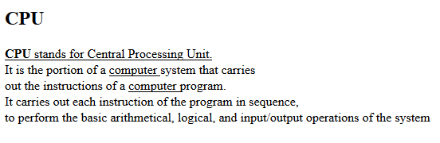

**SOURCE CODE:**

<HTML>

<HEAD>

<TITLE>EXPERIMENT NO 1 </TITLE>

</HEAD>

<BODY>

<h1>CPU </h1>

<p><u><b>CPU</b> stands for Central Processing Unit </u><br>

It is the portion of a <u>computer</u> system that carries <br>

out the instructions of a <u>computer</u> program <br>

It carries out each instructionof the program in sequence,<br>

to perform the basic arithmetical,logical and input/output operations of the sytem. </p>

</BODY>

</HTML>

**OUTPUT:**

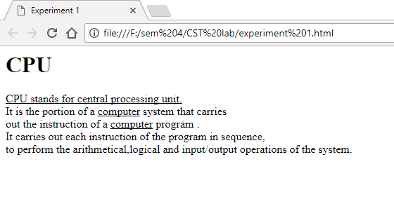

|  |
| --- |
|  |
|  |
|  |
|  |
|  |
|  |
|  |
|  |
|  |
|  |
|  |
|  |
|  |
|  |  |

**PRACTICAL NO. 2**

Aim:Write HTML code for below diagram by using horizontal line, heading tag, colors to suitably distinguish headings, font styling like italics and underline.

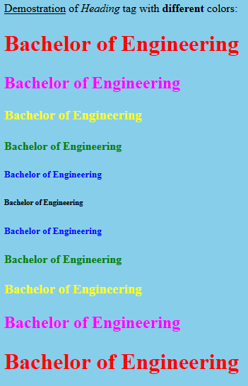

**SOURCE CODE:**

<html>

<head>

<title>

lab 2

</title>

<head>

<body bgcolor="powderblue">

<p><u>Demonstration</u> of <i>Heading</i> tag with <b>different</b> colours:</p>

<font color="red"><h1 >Bachelor of Engineering</h1></font>

<font color="magenta"><h2>Bachelor of Engineering</h2></font>

<font color="yellow"><h3>Bachelor of Engineering</h3></font>

<font color="green"><h4>Bachelor of Engineering</h4></font>

<font color="blue"><h5>Bachelor of Engineering</h5></font>

<font color="black"><h6>Bachelor of Engineering</h6></font>

<font color="blue"><h5>Bachelor of Engineering</h5></font>

<font color="green"><h4>Bachelor of Engineering</h4></font>

<font color="yellow"><h3>Bachelor of Engineering</h3></font>

<font color="magenta"><h2>Bachelor of Engineering</h2></font>

<font color="red"><h1>Bachelor of Engineering</h1></font>

</body>

</html>

**OUTPUT:**

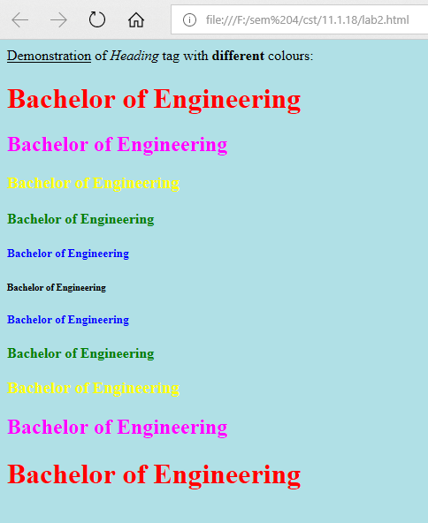

**PRACTICAL NO. 3**

**Aim:** Demonstrate the usage of formatting, marquee and blink tag to print below output.

**Various formulas** (Marquee)

H2O

H2SO4

~~Text~~

X2

X2 + Y2=Z

Y = mx + c

**SOURCE CODE:**

<html>

<head>

<title>

lab 3

</title>

</head>

<body>

<marquee><b>Various formulas</b></marquee>

H<sub>2</sub>O<br>

H<sub>2</sub>SO<sub>4</sub><br>

<del>Text</del><br>

x<sup>2</sup><br>

X<sup>2</sup> + Y<sup>2</sup><br>

Y = mx + c

</body>

</html>

Output:

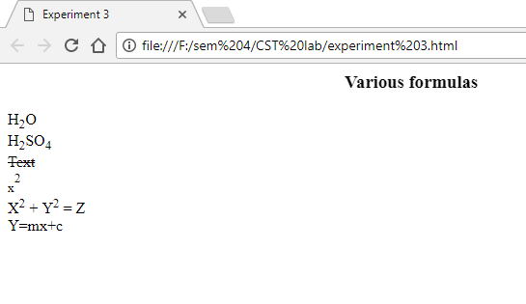

**PRACTICAL NO. 4**

Aim: Write HTML code to display following List

1. Linux
2. Unix
3. HTML
4. DHTML
5. JavaScript
6. Perl
7. PHP
8. SQL
9. Oracle

Source Code:

<html>

<head>

<title>Experiment 4</title>

</head>

<body>

<ol type=1>

<li>Linux</li>

<li>Unix</li>

<li>HTML</li>

<li>DHTML</li>

<li>JavaScript</li>

<li>Perl</li>

<li>PHP</li>

<li>SQL</li>

<li>Oracle</li>

<li>CCNA</li>

</ol>

</body>

</html>

Output:

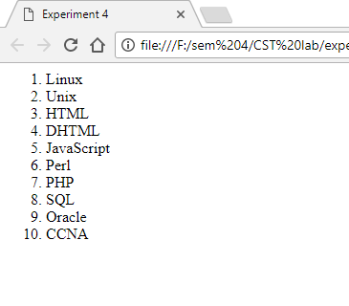

**PRACTICAL NO. 5**

**Aim:** Write HTML code to display following List

Source Code:

<html>

<head>

<title>Experiment 5</title>

<body bgcolor="lightgreen">

<h1>Bachelor of Engineering</h1>

<ul type="disc">

<li>CSE</li>

<ul type="circle">

<li>Software Engineering</li>

<li>Data Structures</li>

<li>Theory of Computation</li>

</ul>

<li>ME</li>

<ul type="circle">

<li>Strength of Computation</li>

<li>Mobility</li>

</ul>

<li>ECE</li>

<ul type="circle">

<li>VLSI design</li>

<li>Wireless communication</li>

</ul>

</ul>

</body>

</head>

</html>

Output:

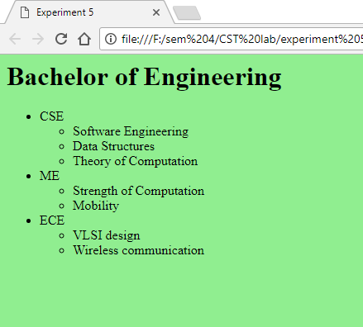

**PRACTICAL NO. 6**

**Aim:** Write the HTML code to add a link on the text “Click here”  and image of “Chitkara university logo”, when you click on these link then  open [www.chitkara.edu.in](http://www.chitkara.edu.in).

Source Code:

<html>

<head>

<title>Experiment 6</title>

</head>

<body>

<center><a href="http://www.chitkara.edu.in/"><img src="img_exp6_1.jpg" height=400 width= 400></a></center>

<center><a href="http://www.chitkara.edu.in/">click here</a></center>

</body>

</html>

Output:





**PRACTICAL NO. 7**

**Aim:** Create a document with two links to an external document. The first link should lead to the beginning of the external document. The second link should lead to a particular section in the external document.

Source Code:

<html>

<head>

<title>Experiment 7</title>

</head>

<body>

<a href="doc7.html">click here</a><br>

<a href="doc7.html#abc">click here</a>

</body>

</html>

Output:

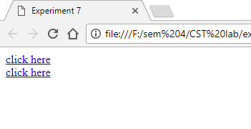

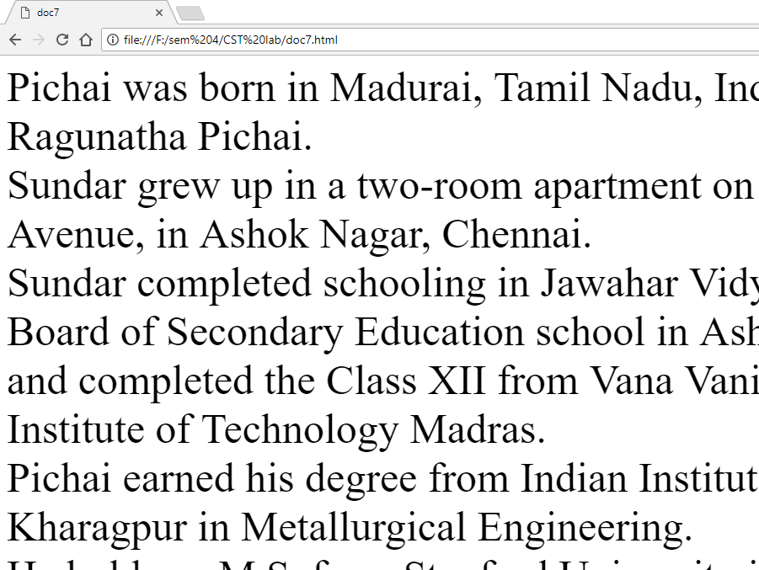

**PRACTICAL NO. 8**

**Aim:** Create an image-map, with clickable regions. Use image of India and create link for any 5 states.

Source code:

<html>

<head>

<title>Expriment8</title>

</head>

<body>

<img src="img_exp8_1.jpg" height=600 width=550 usemap=#map1>

<map name="map1">

<area shape="rect" coords="100 6 240 90" href="https://en.wikipedia.org/wiki/Jammu_and_Kashmir" target="_blank">

<area shape="rect" coords="50 250 150 150" href="https://en.wikipedia.org/wiki/Rajasthan" target="_blank">

<area shape="rect" coords="300 490 170 350" href="https://en.wikipedia.org/wiki/Andhra_Pradesh" target="_blank">

<area shape="rect" coords="400 210 370 180" href="https://en.wikipedia.org/wiki/Sikkim" target="_blank">

<area shape="rect" coords="500 270 470 230" href="https://en.wikipedia.org/wiki/Manipur" target="_blank">

</map>

</body>

</html>

Output:

